**WEBSITE DESIGN BRIEF**



Table of Content

1. INTRODUCTION

2. ABOUT

3. TARGET AUDIENCE

4. WEBSITE ACTIVITIES AND OBJECTIVES

5. NAVIGATION STRUCTURE

6. WEBSITE FEATURES

7. COMPETITOR WEBSITES

8. DESIGN

**1. INTRODUCTION**

This web site is a micro site designed for **Hotel darshan**. Here we focus completely on the Hotel services.

**2. ABOUT HOTEL**

Hotel Darshan founded in 2018, in Gadhinglaj Maharashtra it is family restaurant for veg and nonveg food. They provide all veg nonveg [recipes](https://www.google.co.in/search?q=recipes&spell=1&sa=X&ved=0ahUKEwjav5yElu_cAhUVOSsKHcIJDkwQkeECCCUoAA) with best services.

**3. TARGET AUDIENCE**

**Primary Audience**

a) Young People

b) College students

c) Professional people

d) Families

**Secondary Audience**

a) General Public

b) Competitors

d) Doctors

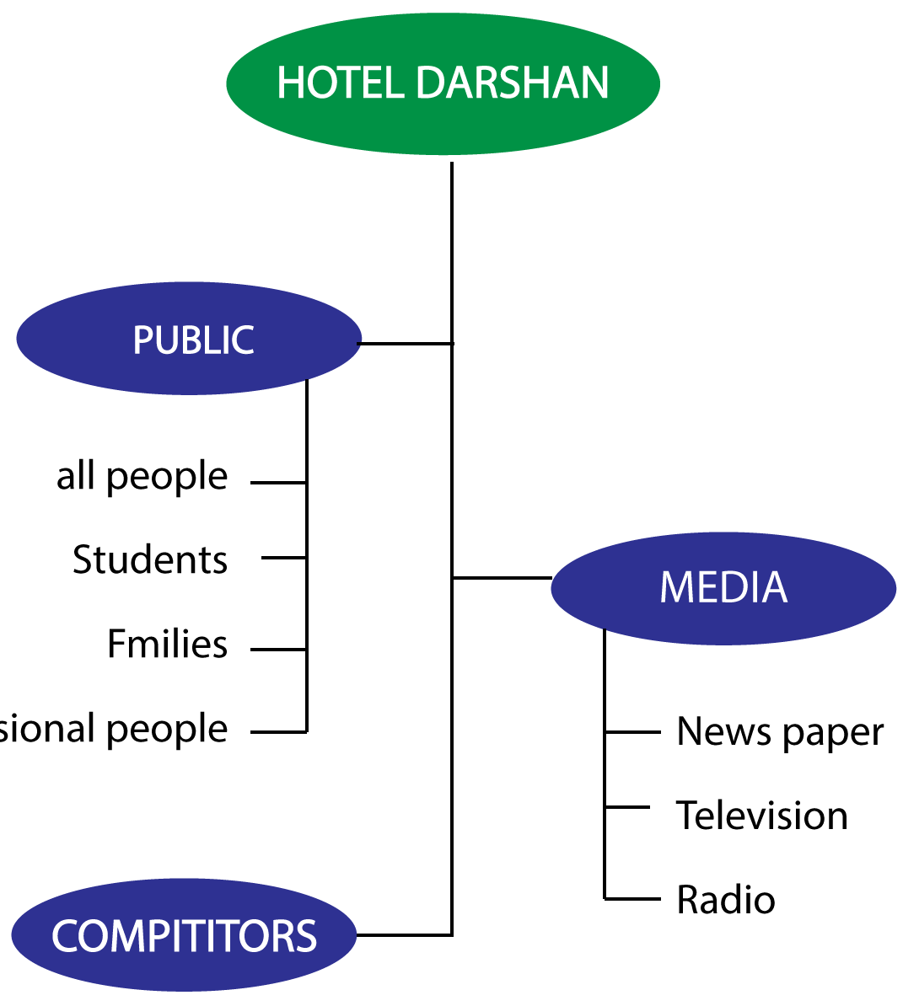

**4.WEBSITE ACTIVITIES AND OBJECTIVES**

**The users can perform the following activities:**

a) Online book or contact

b) Subscribe to the newsletter

c) Follow us on the social media

**The objectives are:**

* To introduce hotel to the people.
* To showcase services and menus to the users.

INFORMATION ARCHITECTURE

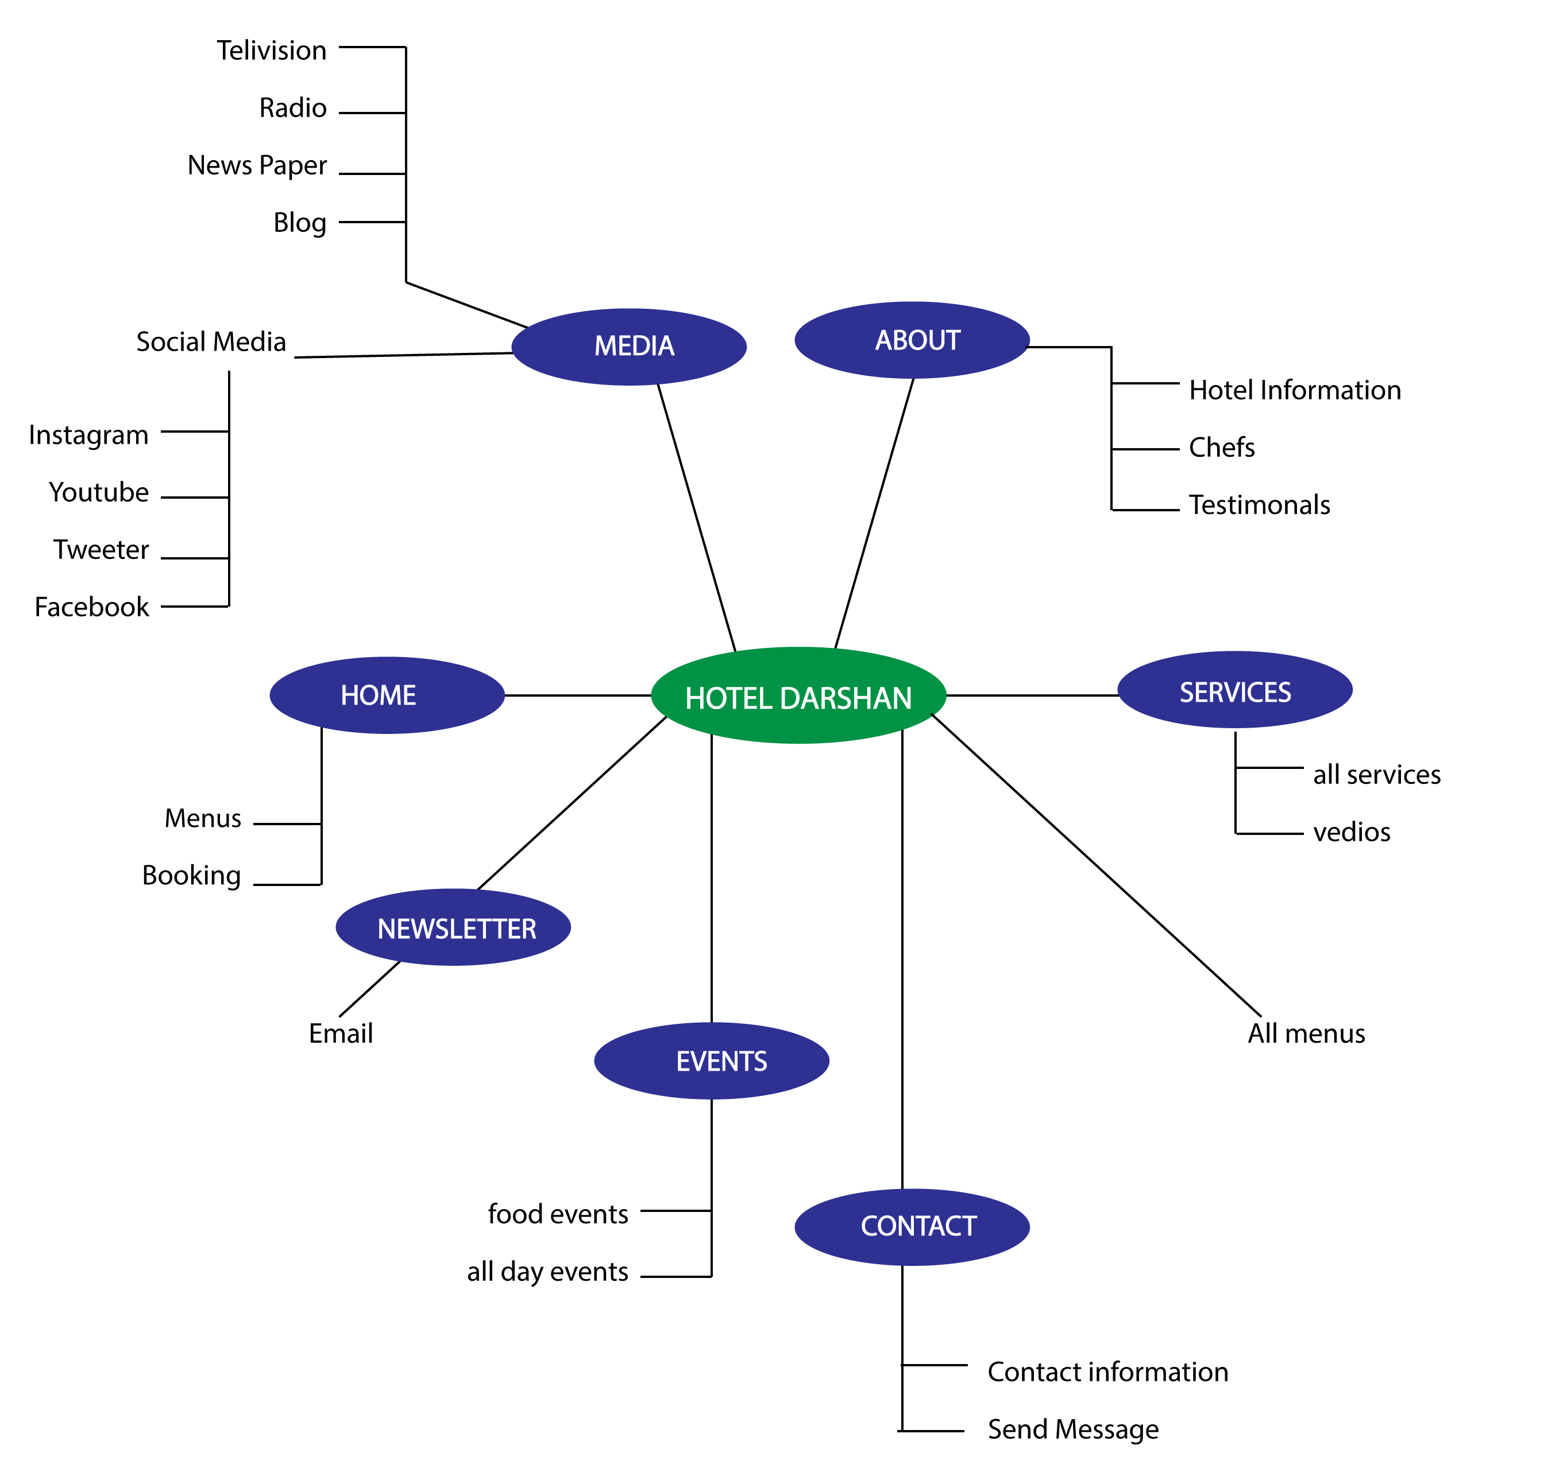

**5. NAVIGATION STRUCTURE**

SITE MAP

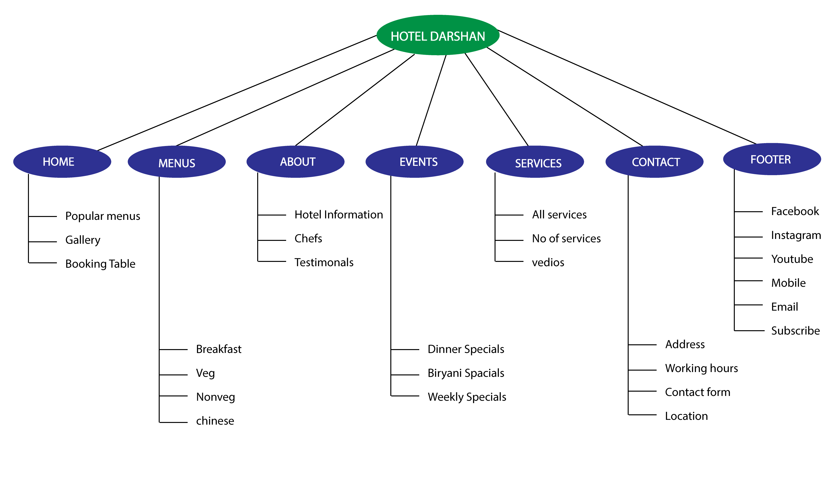

**6 .WEBSITE FEATURES**

* Advance booking
* Newsletter subscriptionλ

**7. COMPETITOR WEBSITE**

**8. DESIGN**

WIREFRAME

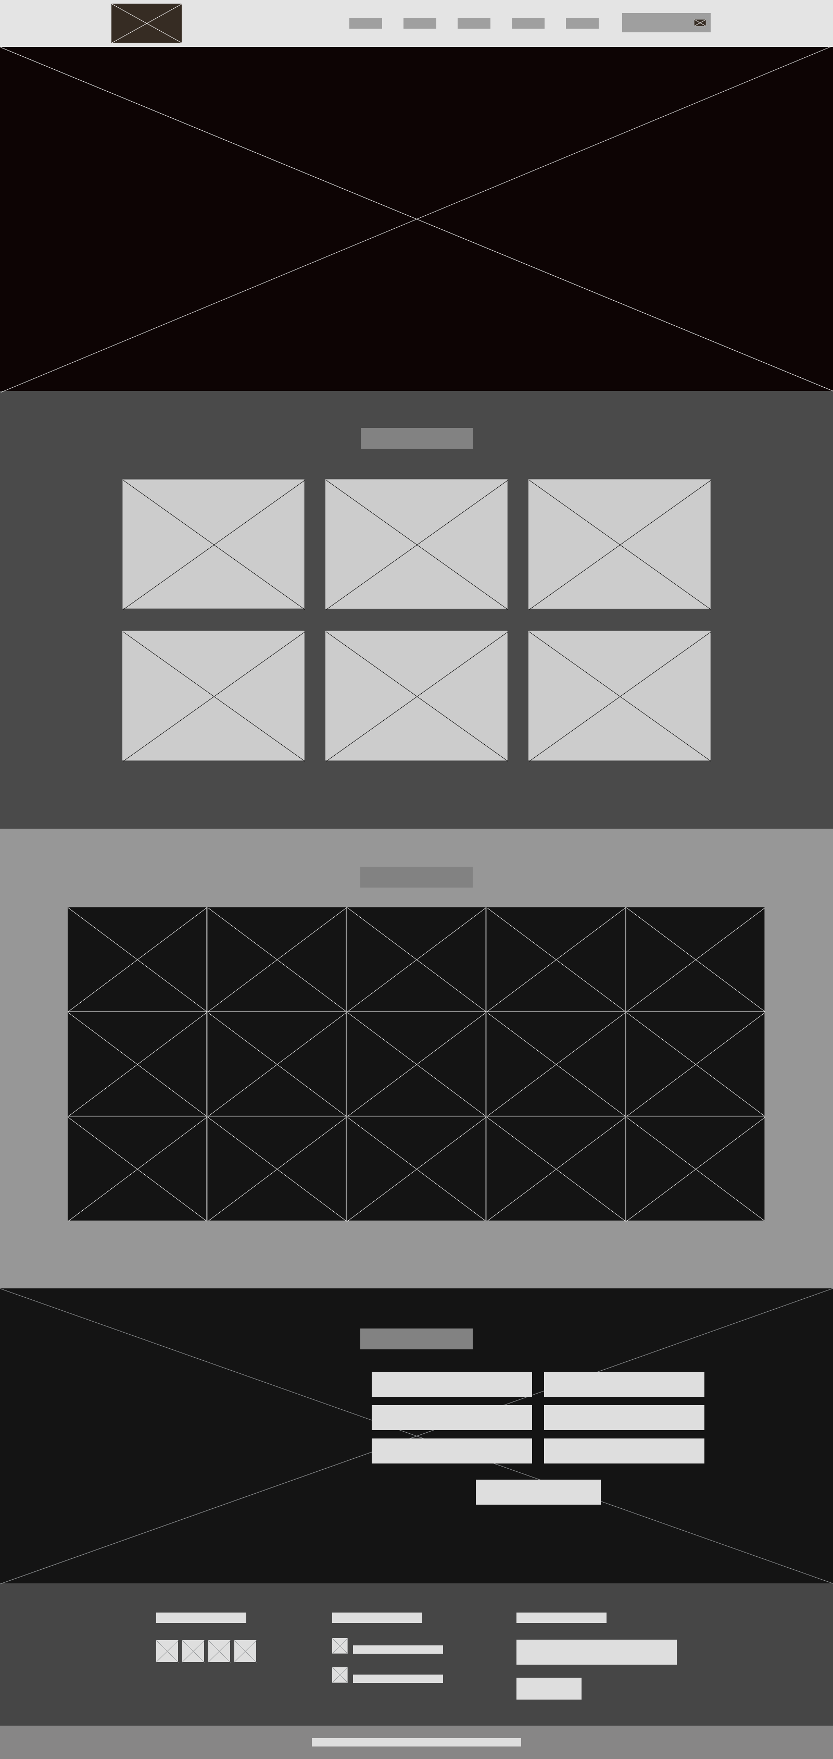

MOCKUP

